|  |
| --- |
| **STUDENT NAME** |
| Alley Chaggar |

**LAB #4**

ACTIVITY 1 2

ACTIVITY 2 6

ACTIVITY 3 10

ACTIVITY 4 12

# ACTIVITY 1

## DRAWING TOOLS

GIMP comes with numerous drawing tools. This tutorial demonstrates some of the basic drawing tools use, designing a simple house.

Follow the steps below:

1. Click File 🡪 New File.
2. Set the dimensions to 600x500 and press OK.
3. Click on the left of side of the grid and set the rulers (watch the **Setting the Guides** video).
4. At the Layers right – click 🡪 Add New Layer.
5. Set the name to Layer2, the dimensions to **600x500**.
6. Select a rectangular area at the middle to bottom of the image.  
     
   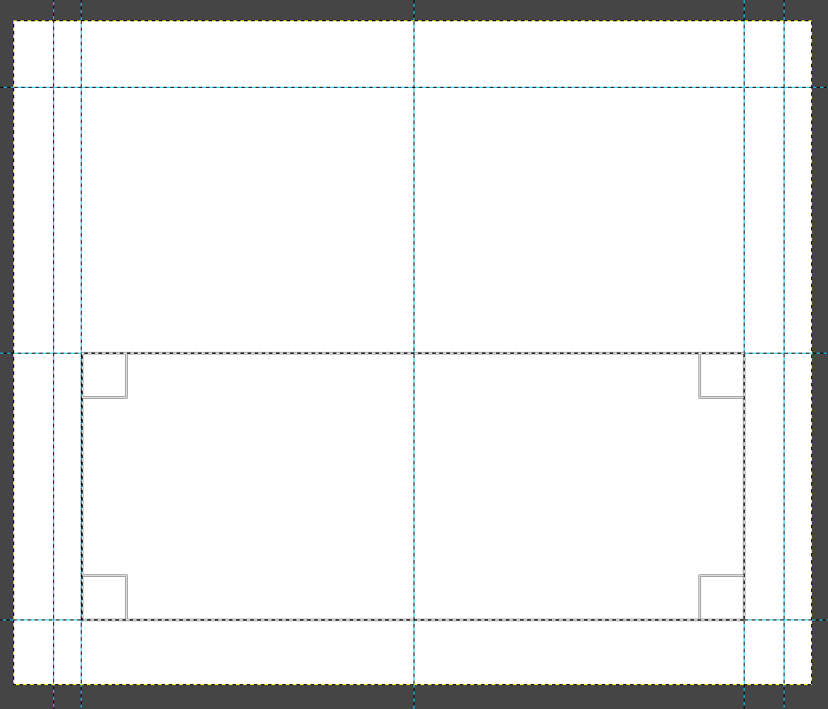
7. Click Edit 🡪 Stroke Selection and set the options as shown below:  
     
   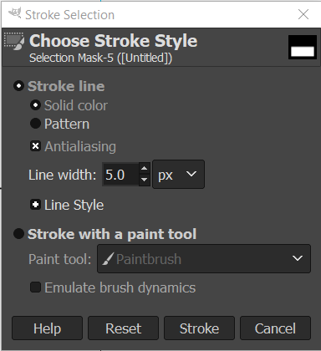
8. Click Stroke.
9. Pick a green Foreground color and a light-Yellow background color.
10. Click on the Gradient tool.
11. Click on the Paths Tools.
12. Select a Black foreground color and draw a roof as shown below (use the Guides):  
      
    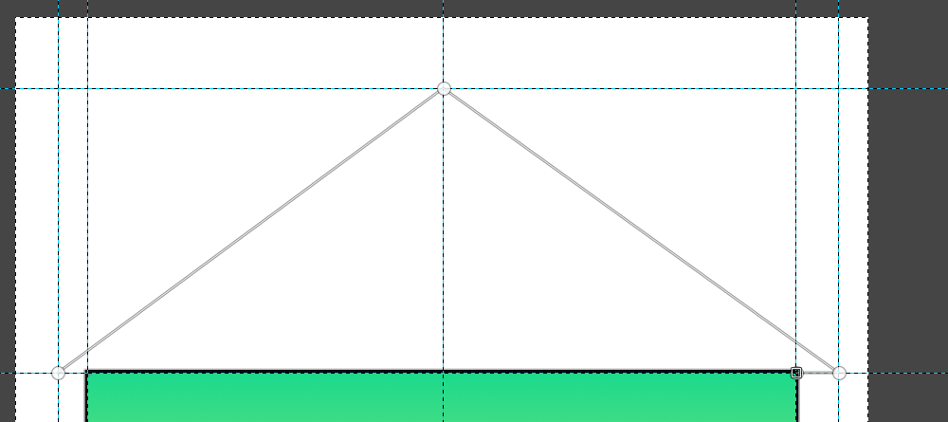
13. Click Edit under the Paths of the Path Tools.
14. Select Stroke Path under the Paths Edit Mode.
15. Set the settings as shown below:  
      
    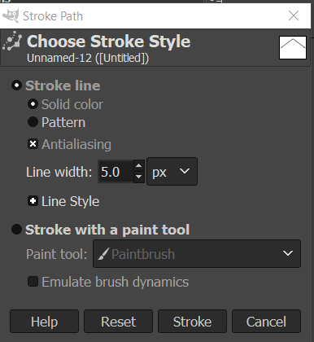
16. Click Select 🡪 None
17. Click on the Bucket tool and click on the Pattern fill.
18. Pick the Java pattern.
19. Click inside the roof.
20. Click on the Rectangle selection tool and draw a rectangle as a door.
21. Pick a blue foreground and a white background color and click on the Gradient tool.
22. Hold and drag from the left to the right of the door.
23. Click on the Rectangle selection tool and draw a rectangle as a doorstep.
24. Click on the Bucket tool and select the Pattern Fill.
25. Pick the Brick pattern and click in the doorstep as shown below:  
      
    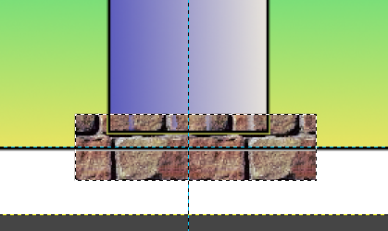
26. Follow steps 20 – 22 to draw two windows and fill them with a Gradient color.
27. Select the Ellipse Tool and draw a door handle.
28. Click on the Bucket tool, pick a pattern and fill the handle.
29. Keep under the Bucket tool, click on the FB Color.
30. Pick a black color and click on the background of the image.
31. Export the image as Home.png.

|  |
| --- |
| **TASK 1.1:**  Locate the Home.png file and add it to the submission folder. |
| upload iconIn the LMS, add the file to the assignment Lab #4 submission folder. You can submit multiple files at a time. |

# ACTIVITY 2

## CREATING UI ELEMENTS

The User Interface (UI) are important assets for every computer game. From a button to a logo these assets provide the users with a handy and beautiful interface. This activity demonstrates how to draw some of these elements.

Follow the steps below:

1. Click File 🡪 New…
2. Set the dimensions to 2048x2048 and press OK.

**Rectangular Button**

1. Set the Foreground and Background color to Black.
2. Under the Layers right – click 🡪 New Layer.
3. Set the Fill with option to **Transparency**.
4. Click Image 🡪 Configure Grid.
5. Set the Horizontal and Vertical Spacing to 512 and press OK.
6. Click View 🡪 Show Grid.
7. Click at the Rectangle Selection tool and, at the upper left corner, draw a button.
8. At the Rectangle Selection tools settings select the Rounded corners option and press Enter.
9. Click on the Gradient color Tool.
10. Set the Foreground color to something Blue and the background to Black.
11. Select the FG to BG option and Linear RGB.
12. Click on the top-left side of the button and drag toward the bottom-right.
13. The button should look, such as the one below:  
      
    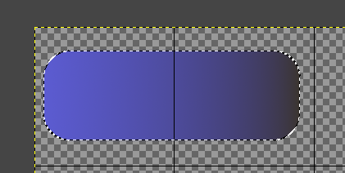
14. Click on the Airbrush tool.
15. Set the Opacity to 50, the Size to 90 and Aspect Ratio to 0.
16. Click on the Foreground color and pick the same color but brighter.
17. Draw some glumness on the top of the button and some darkness at the bottom as shown below:  
      
    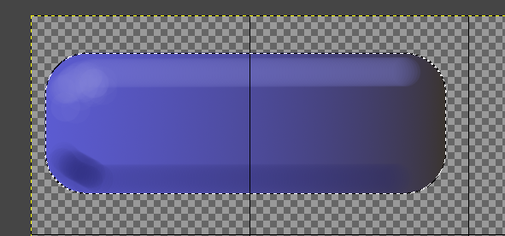
18. Press Ctrl+Shift+A and remove the border.

|  |
| --- |
| **TASK 2.1:**  Take a screenshot of GIMP image and paste it below: |
|  |

**Circular Button**

1. Click on the Ellipse Tool.
2. Draw a Circle inside the grid as shown below:  
     
   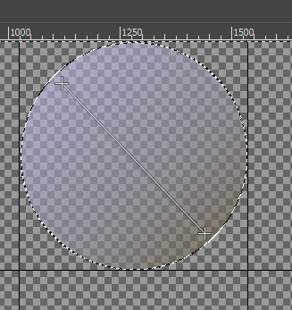
3. Click on the Gradient Tool.
4. Set the Transparency to 50, the Foreground color to a Gray one and the Background to pale Brown.
5. Click on the top left and drag toward the bottom right side of the circle.
6. Click on the Gradient Tool again and set the Transparency to 98.
7. Press Ctrl + Shift + A.

**Arrow Button**

1. Select the Rectangle Tool (keep the previous settings).
2. Draw a smaller rectangle.
3. Set the color to pale brown and click on the Bucket tool.
4. Click in the new rectangle.
5. Press Ctrl + Shift + A.
6. Pick the Paintbrush tool.
7. Set the size to 130 and the color to pane brown.
8. Draw an arrowhead as shown below:  
     
   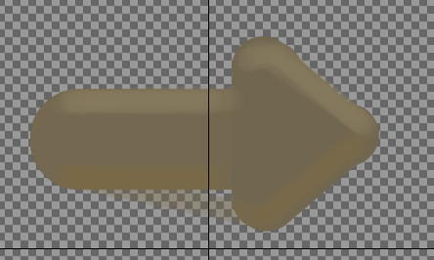
9. Click on the Airbrush and pick a lighter brown color.
10. Draw the upper side of the arrow.
11. Pick a darker brown color and draw the bottom side of the arrow as shown below:  
      
    

**Background Image**

1. Select all the bottom image area with the Rectangle tool.
2. Click on the Gradient color tool and pick a Red color for foreground and a Black for background.
3. Hold the left mouse button and drag toward the bottom of the rectangle.
4. Click File 🡪 Export.
5. Export as UIButtons.png and store it to your computer.

|  |
| --- |
| **TASK 2.1:**  Locate the UIButton.png file and add it to the submission folder. |
| upload iconIn the LMS, add the file to the assignment Lab #4 submission folder. You can submit multiple files at a time. |

# ACTIVITY 3

## IMPORTING UI ASSETS TO UNITY

The next step of the process is to import and configure the UI elements, before we use them in a game. This tutorial demonstrates this process, of importing those assets, transforming them to Unity sprites and it also introduces us to basic animation.

Follow the steps below:

1. Double click on Unity Hub.
2. Click the **New** button.
3. Create a new 2D Project and select its path.
4. When Unity starts, under the Project tab, right – click 🡪 New 🡪 Folder.
5. Name the new folder, UI.
6. Inside the UI folder, right – click 🡪New 🡪 Folder.
7. Name the new folder, Buttons.
8. Double click on the Buttons folder and open it.
9. Inside the buttons folder, right – click 🡪 Import Assets…
10. Pick the UIButtons.png file.
11. Click on the UIButtons assets and under the Inspector set the options as shown below:  
      
    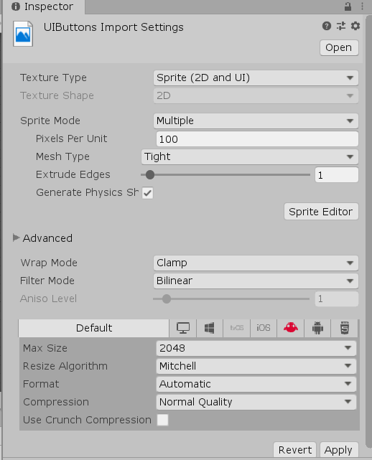
12. Click Apply.
13. Click Sprite Editor.
14. Click Slice 🡪 Automatic 🡪 Slice.
15. Click on each one of the new sliced sprites and name them Rectangular_Button, Circular_Button, Arrow_Button and Background.
16. Click Apply.
17. Close the Sprite Editor clicking on the x button.
18. Expand the UIButtons asset.

|  |
| --- |
| **TASK 3.1:**  Take a screenshot of the Unity main window, displaying the sliced UIButtons and paste it below: |
|  |

# ACTIVITY 4

## CREATING A BASIC INTERFACE IN UNITY

The last step of the process is the basic interface design using the newly imported assets. This activity demonstrates how to combine the assets and some Unity elements, so that we can design a User Interface.

Follow the steps below:

1. Right – click on the Hierarchy tab 🡪 UI 🡪 Canvas.
2. Under the Canvas element, right – click 🡪 UI 🡪 Panel.
3. Click on the Panel and at the Inspector, in the Source Image element drag and drop the Rectangular_Button Sprite.
4. Change the name Button to PlayButton.
5. At the Text under the Button, under the Text type **Play**.
6. Set the Transition to Color Tint and under the highlights select different color variations
7. Repeat steps 1 – 6, but name the Button LoadButton and at the Text type **Load Game**.
8. Repeat steps 1 – 6, but name the Button GameOptionsButton and at the Text type **Game Options**.
9. Repeat steps 1 – 6, but name the Button CreditsButton and at the Text type **Credits**.
10. Repeat steps 1 – 6, but name the Button ExitButton and at the Text type **Exit Game**.
11. Repeat steps 1 – 6, but name the Button AccountButton, at the Text type Access Account and under the Source Image drag and drop the Circular Button Sprite.
12. Repeat steps 1 – 6, but name the Button NextScreenButton, at the Text type **Next Screen** and under the Source image drag and drop the Arrow Button Sprite.
13. Arrange the buttons as shown below:  
      
    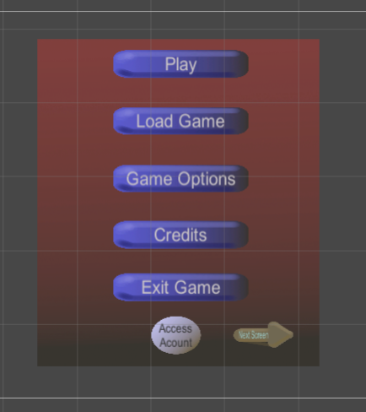
14. Press the Play Button.

|  |
| --- |
| **TASK 5.2:**  Take a screenshot of the Unity Game Scene, while the game is playing and paste it below: |
|  |

Advanced:

|  |
| --- |
| **TASK 4.2:**  Draw an arrow heading to the other direction and add it to the Unity project with the Last Screen caption and Text. Take a screenshot of the output in the Unity Editor and paste it below: |
|  |

FINAL STEP: Save this document as a PDF. Upload the PDF to the Lab #4 submission folder.